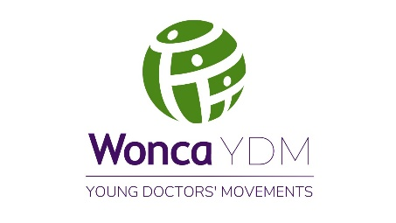

STRUCTURED APPLICATION

FOR THE WONCA WORLD RISING STAR AWARD 2025

***Important***

* ***Please include all the details relevant to you in each section.***
* ***Do not delete any section/question.***
* ***Send this document as a Microsoft Word document.***

**Name:**

**Country:**

**Gender:**

**Date of Birth:**

**Date of first Family Medicine qualification received (if any):**

**Current Designation:**

**Place of Work:**

**TRAINING AND QUALIFICATIONS**

1. **Postgraduate qualification/s in Family Medicine/General Practice**

* **Qualification/s:**
* **Qualification awarding institution/s:**

**OR**

**If still in training**

* **Name of the qualification:**
* **No of training years completed:**

1. **Fellowships/Certificate courses/ Special Interest training after post-graduation**

**CONTRIBUTION TO FAMILY MEDICINE EDUCATION**

1. **Involvement in teaching, training and mentoring in Family Medicine/General Practice**

**LEADERSHIP**

1. **Leadership and responsibilities in Young Doctors’ Movement in your country/region or global level**
2. **Leadership and responsibilities in national organization in Family Medicine/General Practice/primary care**
3. **Leadership and responsibilities in regional/global organizations in Family Medicine/General practice/primary care**

**SIGNIFICANT ACHIEVEMENTS**

1. **Significant awards/achievements/distinctions related to primary care**

**ADVOCACY**

1. **Involvement in advocacy work (local/national/regional/international)**

**CONTRIBUTION TO SCIENCTIFIC ACTIVITIES, RESEARCH AND PUBLICATIONS**

1. **Experience in presenting as a resource person in national/regional and international conferences or webinars**
2. **Experience in presenting as a speaker in local workshops/symposium or webinars**
3. **Oral/poster presentation of research work in national, regional or international Conferences**
4. **Publications in Scientific Journals**
5. **Publication of articles in academic newsletters or websites related to primary care**

**COMMUNITY WORK**

1. **Activities related to increasing patient awareness and health education, including print, electronic and social media activities (provide links in web-based activities)**
2. **Community work and volunteerism in the capacity of family doctor**
3. **Social and community activities external to Family Medicine/primary care**

**TEAM WORK**

1. **What are your success stories as a team player and team leader in primary care?**

***(Max 150 words)***

**STATEMENT BY THE APPLICANT**

I certify that the above information is true and accurate to the best of my knowledge and I know that providing false information will disqualify me from the selection process.

I am prepared to provide further details and evidence of the above mentioned information if requested by WONCA YDM.

**Name:**  **Date:**

**E Signature:**

**CERTIFICATION BY THE REGIONAL YDM CHAIR**

[Name of the candidate] applicant has been selected as the candidate from the YDM of WONCA [WONCA Regions name] Region for the WONCA Rising Star Award.

She/He is a young doctor according to WONCA guidelines and I certify that the above details are correct to best of my understanding.

**Name:**  **Date:**

**E Signature:**